Autumn 1 Newsletter
Year 4
Dear Year 4 Parents and Guardians,

Year 4 has had a fantastic start to the Autumn term with lots of brilliant learning taking place across the curriculum.
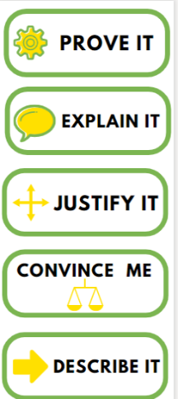
In maths, we will be deepening our knowledge of place value and will be looking at rounding, finding 1,000-more and 1,000-less, greater and less than (including using the symbols: >, <, =) and ordering numbers from ‘smallest’ to ‘greatest’. In the next three weeks, we will be moving on to addition and subtraction. The children will be securing their knowledge and fluency on adding and subtracting 2 and 3-digit numbers before moving on to 4-digits. Along the way, there will be problem solving opportunities and time for children to reason and reflect on the various strategies introduced over the term. Please see the additional information below for details on how you can help your child with maths. Children will be learning their Multiplication Timestables each work but will need to practise regularly at home also.

We will be sharing some wonderful texts together this term in literacy, which have already inspired some brilliant ideas for writing! These include, ‘A Bear Called Paddington’ by Michael Bond, ‘Charlie and the Chocolate Factory’ by Roald Dhal and ‘The Rhythm of the Rain’ by Grahame Baker-Smith. The children will be focussing on sentence construction, using adjectives to describe and time-connectives to sequence their ideas.

…Which leads us to science! Science this term has been all about states of matter, (solids, liquids and gases). Enquiry and investigations are at the heart of our experience of science. We will be building the children’s knowledge of how materials can change through freezing and melting different liquids. We will also be investigating viscosity, why some liquids pour more easily than others. In the coming weeks, we will move on to evaporation, condensation and their role in the water cycle.

The wider curriculum has also provided us with some great learning experiences this term. We have been learning about Hinduism in RE with a view to building the children’s understanding of what it could mean to belong to a religion. E-safety will be our main focus in Computing whilst we learn about networks and the internet. We will be thinking about how information is moved around networks using routers and why it is important to keep these secure. In History, we have begun looking at the Roman Empire and its impact on Britain. Having evaluated the reasons why Rome was able to expand, we have been looking at how Britain changed under Roman rule.
For an overview of all subjects, please visit the ‘Curriculum’ page on the Halstow website: https://www.halstow.greenwich.sch.uk/node/3
PE Days:
Both classes have both of their PE sessions on Tuesdays.
Can the children wear trainers and comfortable clothes on these days please! Remember to bring your swimming costume and a towel also every Tuesday.

We look forward to sharing some of the children’s wonderful learning with you at parents evening later this term.

All the best to you and your families,
Mrs Dearness and Miss Hills
Maths Additional Info:
We will roughly be following the ‘White Rose’ (https://whiterosemaths.com/) sequence of learning in maths across the year. Here is an overview of what we will cover. Please note that this is only an outline of what will be covered. Our lesson content will be closely tailored to the children in our classes.

Resources for parents
Follow this link for access to resources for parents provided by White Rose Maths https://whiterosemaths.com/parent-resources
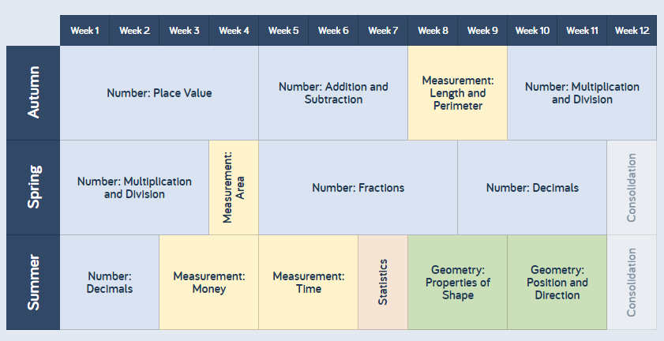
Maths Overview:
We are always working on helping the children build their fluency in recalling key number facts.
